Solar Stormwatch Resources
You are encouraged to use the resources featured on the project website (http://solarstormwatch.com/). There are videos and pertinent information highlighted throughout the site, for example:
- http://www.solarstormwatch.com/why_scientists_need_you , features five short videos which partly explain why your analysis is pertinent. Moreover, the Royal Observatory’s Becky Higgitt reveals the long history of solar science at Greenwich.
- http://www.solarstormwatch.com/spot_and_track/spot/screencast, features video clips describing each subproject and guides you through the training. The “Spot” challenge is characterized here http://www.solarstormwatch.com/spot_and_track/spot/screencast, whereas the “What’s that?” project is detailed here http://www.solarstormwatch.com/spot_and_track/whats_that/screencast.
- The Mission Briefing site, http://www.solarstormwatch.com/mission_briefing, provides background information concerning the Solar phenomena discussed and the spacecraft which acquired the images. For example, the following link features information about the Stereo Spacecraft (http://www.solarstormwatch.com/mission_briefing/the_stereo_spacecraft). The blue ‘i’ (information) icon can be selected to obtain relevant details, as shown in the screenshot below.
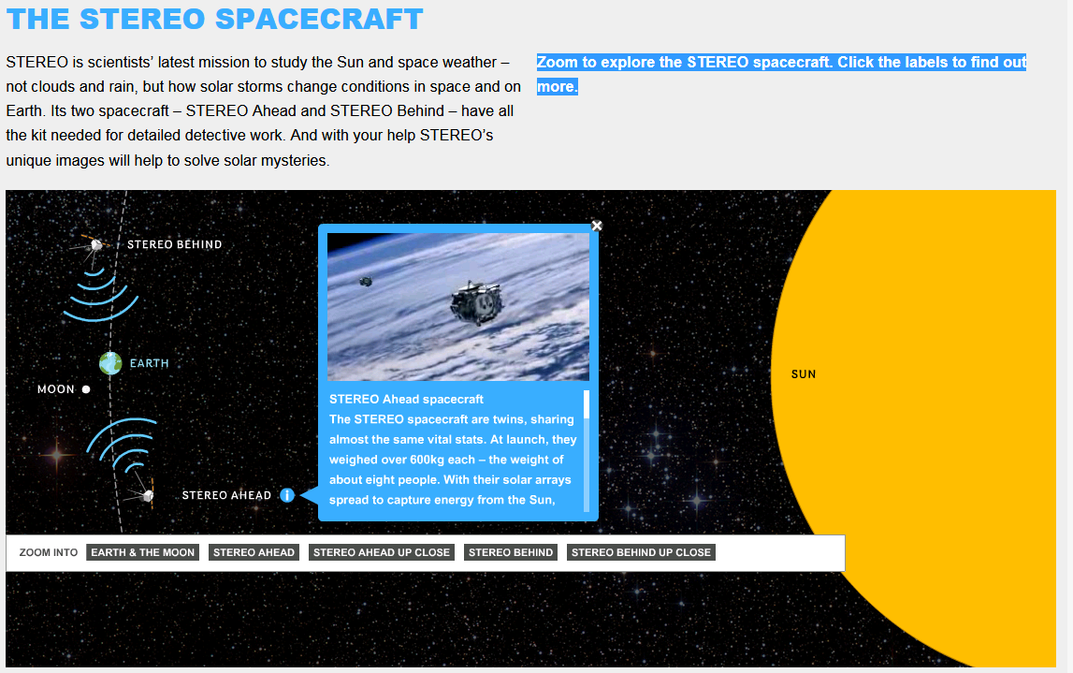
© Solar Stormwatch 2009, under the terms of the Creative Commons Attribution-Noncommercial-No Derivative Works 2.0 UK: England & Wales License.

